1. *Explain the Bluetooth operations.*

The Bluetooth is a short-range communication tool developed by the Bluetooth SIG. It is designed as a low-power solution for control and monitoring applications.

The Bluetooth network is configured as ‘Master-slave configuration’, which is composed of central and peripheral devices. Central devices scan the peripherals for connection, and peripheral devices broadcast the advertising packet regularly.

The protocol Stack is as followed.

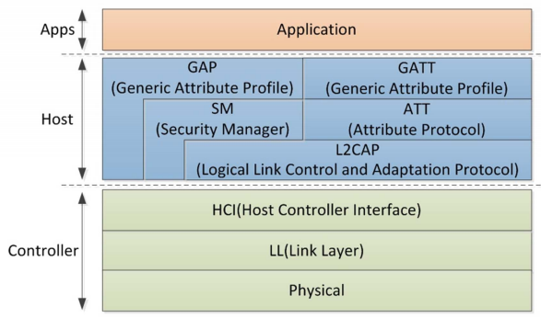

GAP, or generic access profile, determine the role of the devices. Central (broadcaster), and peripheral (observer). It controls the advertising and connection procedures. GATT, or generic attribute profile, defines the data transmit/receive procedures using services and characteristics. GAP is uppermost control layer, while GATT is uppermost data layer.

Bluetooth low energy connection scenario is as follows.

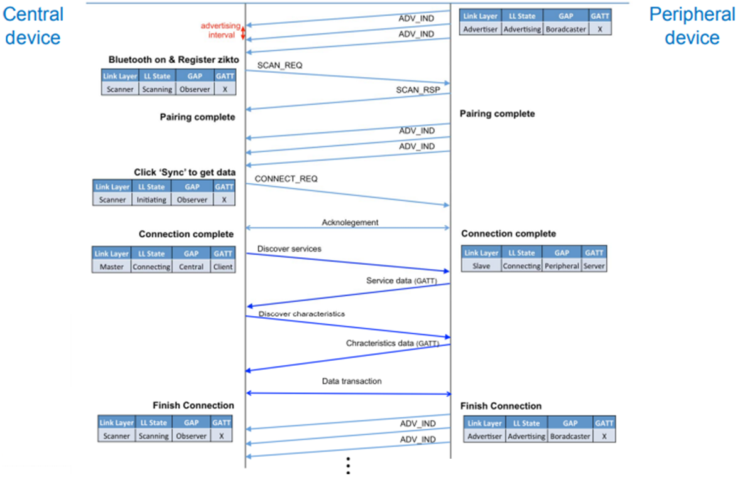

Pairing -> Synchronization -> Conection

1. *Investigate a central and a peripheral roles in Bluetooth.*

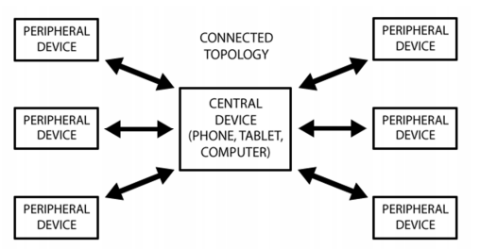

Bluetooth topology follows ‘Master – slave configuration’.

Central devices (Observer) scan the peripherals for connection.

Peripheral devices (Broadcaster) broadcast the advertising packet regularly.